Architecture Document for the Design, Development and Deployment of AI Powered Learning Portal for STEM Students

Team Members: Nathan Gulley
Gideon Idowu
Ahmed Kareem

To: Prof. Worrel Morgan
Regis University
MSSE692 Software Engineering Practicum I

Date: February 1st , 2026

Executive Summary
STEMulator adopts a modular monolithic frontend architecture with a service-oriented AI integration layer, designed to support interactive STEM simulations while remaining lightweight, extensible, and maintainable within an academic practicum context. The core system is implemented as a single React application organized into feature-based modules (Home, Courses, Labs, Lab Player, AI Panel), with clear internal boundaries between UI components, simulation logic, state management, and external integrations. This approach balances architectural rigor with practical constraints, enabling rapid iteration without sacrificing structure.
The central architectural decision is to treat the Lab Player as a reusable core shell that dynamically loads different lab modules based on configuration. Each lab is implemented as a self-contained module exposing a standardized interface including metadata, input schema, simulation logic, output schema, and visualization configuration. This design allows new labs to be added without modifying the main application flow, directly supporting extensibility and maintainability. Simulation logic is implemented as pure TypeScript functions and decoupled from UI rendering, ensuring deterministic behavior, testability, and improved performance.
AI integration is handled through a dedicated backend API gateway that mediates all communication with external AI services. The frontend generates structured “lab snapshots” containing current inputs, outputs, and recent user actions, which are sent to the backend for processing. This design supports security by preventing exposure of API credentials, reliability through retry and error handling without losing lab state, and future scalability by allowing AI providers to be replaced or extended without impacting the frontend architecture.
The architecture directly addresses the top three quality attribute priorities identified in Week 2. Performance is achieved through precomputed simulation datasets, separation of animation loops from React rendering, and efficient state updates using hooks and reducers. Reliability is supported through state preservation, graceful handling of AI failures, and deterministic simulation logic. Security is enforced by isolating all AI communication behind a server-side layer and avoiding client-side exposure of sensitive credentials or persistent user data.
Several trade-offs were intentionally accepted. The system uses a modular monolith rather than microservices to avoid unnecessary complexity within the eight-week timeline. No persistent storage or authentication is included, prioritizing core learning functionality over platform features. Scientific models are simplified to favor conceptual learning and responsiveness over physical accuracy. Overall, architecture emphasizes interactivity, extensibility, and pragmatic delivery while remaining suitable for future expansion.

Architectural Drivers Analysis
Top 3 architectural drivers from Week 2 quality attribute scenarios
- Performance
Week 2 reference: QA-1 Performance (Simulation Response Time) and QA-2 Performance (AI Guidance Latency)
Why this drives architecture: STEMulator is an interactive learning platform. If simulation runs and UI updates are slow, students disengage quickly and the platform fails its primary educational purpose. Performance is also a credibility issue. A lab that feels laggy or unresponsive will be perceived as broken or unreliable even if it is technically correct.
Business impact if not addressed architecturally: Poor performance directly reduces user engagement and learning outcomes, undermines demo value, and prevents adoption as a classroom-ready tool. It also forces late-stage refactoring if performance problems emerge after features are built.
Architectural implications:
· Keep simulation logic decoupled from UI and implement it as pure functions.
· Precompute datasets per run instead of recalculating during rendering.
· Isolate Canvas animation from React render cycles using refs and requestAnimationFrame.
· Use efficient state updates (useReducer, scoped state) to avoid unnecessary re-renders.
- Reliability
Week 2 reference: QA-3 Reliability (Session Continuity during AI failure)
Why this drives architecture: The system depends on an external AI provider, which introduces latency, timeouts, and occasional failures outside the team’s control. If an AI request fails and the user loses lab state, the learning session breaks and the platform becomes frustrating to use. Reliability here is defined as continuity of the learning experience rather than infrastructure uptime.
Business impact if not addressed architecturally: Students lose progress and trust in the platform. Demos become high risk because AI failures can derail the session. The team also loses the ability to diagnose issues if failures are not handled consistently.
Architectural implications:
· Preserve lab state independently from AI requests.
· Design AI calls as optional enhancements, not blockers to running simulations.
· Provide clear retry flows and user-friendly errors without resetting the lab.
· Centralize AI request handling so failures are managed consistently.
- Security
Week 2 reference: QA-4 Security (API Key and Data Protection)
Why this drives architecture: AI integration requires secrets. If keys are exposed in client code or network responses, the project becomes unsafe to demo and could lead to unauthorized usage and cost exposure. Even without user accounts, protecting credentials is a baseline expectation for professional software engineering.
Business impact if not addressed architecturally: Key leakage creates financial risk and reputational damage, and it can force the team to redesign integration late in the project. It also weakens the project as a portfolio artifact because insecure patterns are immediately visible to reviewers.
Architectural implications:
· Route all AI calls through a backend API gateway.
· Store API keys server-side only.
· Send only minimal, structured lab snapshots and avoid sensitive data collection.
· Enforce consistent request and error handling at the integration boundary.
Architecture Overview
Overall architectural style and pattern:
STEMulator uses a modular monolith with a layered frontend structure and a thin service boundary for external integrations. The primary deliverable is a single React + TypeScript web application organized by feature modules (Courses, Labs, Lab Player, AI Coach) rather than by technical layers alone. This style keeps development and deployment simple for an 8-week project while still enforcing clear internal boundaries so additional labs, modules, and future backend capabilities can be added without major refactoring.
Key structural elements
1. Presentation layer (React UI)
Responsibilities
- Provides navigation, course/module browsing, and lab selection.
- Hosts the Lab Player experience (simulation view, controls, results, AI coach).
- Enforces input validation and displays user-friendly error states.
- Major UI modules
- Home and Navigation: menu, search, routing, and layout shell.
- Course Explorer: course catalog, module list, course detail pages.
- Lab Explorer: lab catalog, filtering, and launch flow.
- Lab Player: reusable shell that loads a lab module based on a labId and config.
- AI Coach Panel: chat interface plus quick actions like Explain, Hint, Check Reasoning.
2. Domain and data model layer (TypeScript types)
Responsibilities
- Defines strongly typed models for Course, Module, Lesson, Lab, LabInputs, LabOutputs, and LabSnapshot.
- Provides a consistent contract for adding labs and associating them with course modules.
3. Simulation layer (lab modules and simulation engine)
Responsibilities
- Implements simulation logic as pure TypeScript functions (deterministic, testable).
- Generates outputs and datasets for charts and Canvas animation.
- Exposes a standardized lab module interface so new labs plug into the Lab Player without rewriting the shell.
4. State management layer (React hooks, context, reducer)
Responsibilities
- Manages lab state (inputs, outputs, run history, event log).
- Preserves state across AI calls and error conditions.
- Produces lab snapshots for AI guidance requests.
Integration approach
Internal communication
- React props for component composition.
- Context and useReducer for shared lab state across Lab Player subcomponents.
- A lab module registry (configuration-driven) to load labs by identifier.
External communication
- For the prototype: AI calls can be mocked or routed through a thin backend endpoint.
- If enabled: REST calls to a backend AI gateway endpoint (for example, /api/ai) that forwards requests to an AI provider. This protects secrets and provides consistent error handling. No message queues are required for the MVP.
Deployment architecture
Current deployment
- Static frontend deployment on a platform such as GitHub Pages.
- CI pipeline can run linting, tests, and a production build before deployment.
Planned deployment extension (if backend is introduced)
- A small backend service deployed alongside the frontend to serve AI requests and keep API keys server-side.
- Containerization with Docker is optional but recommended if the backend is added to ensure consistent environments across development and deployment.
Architecture Views (C4 Model):

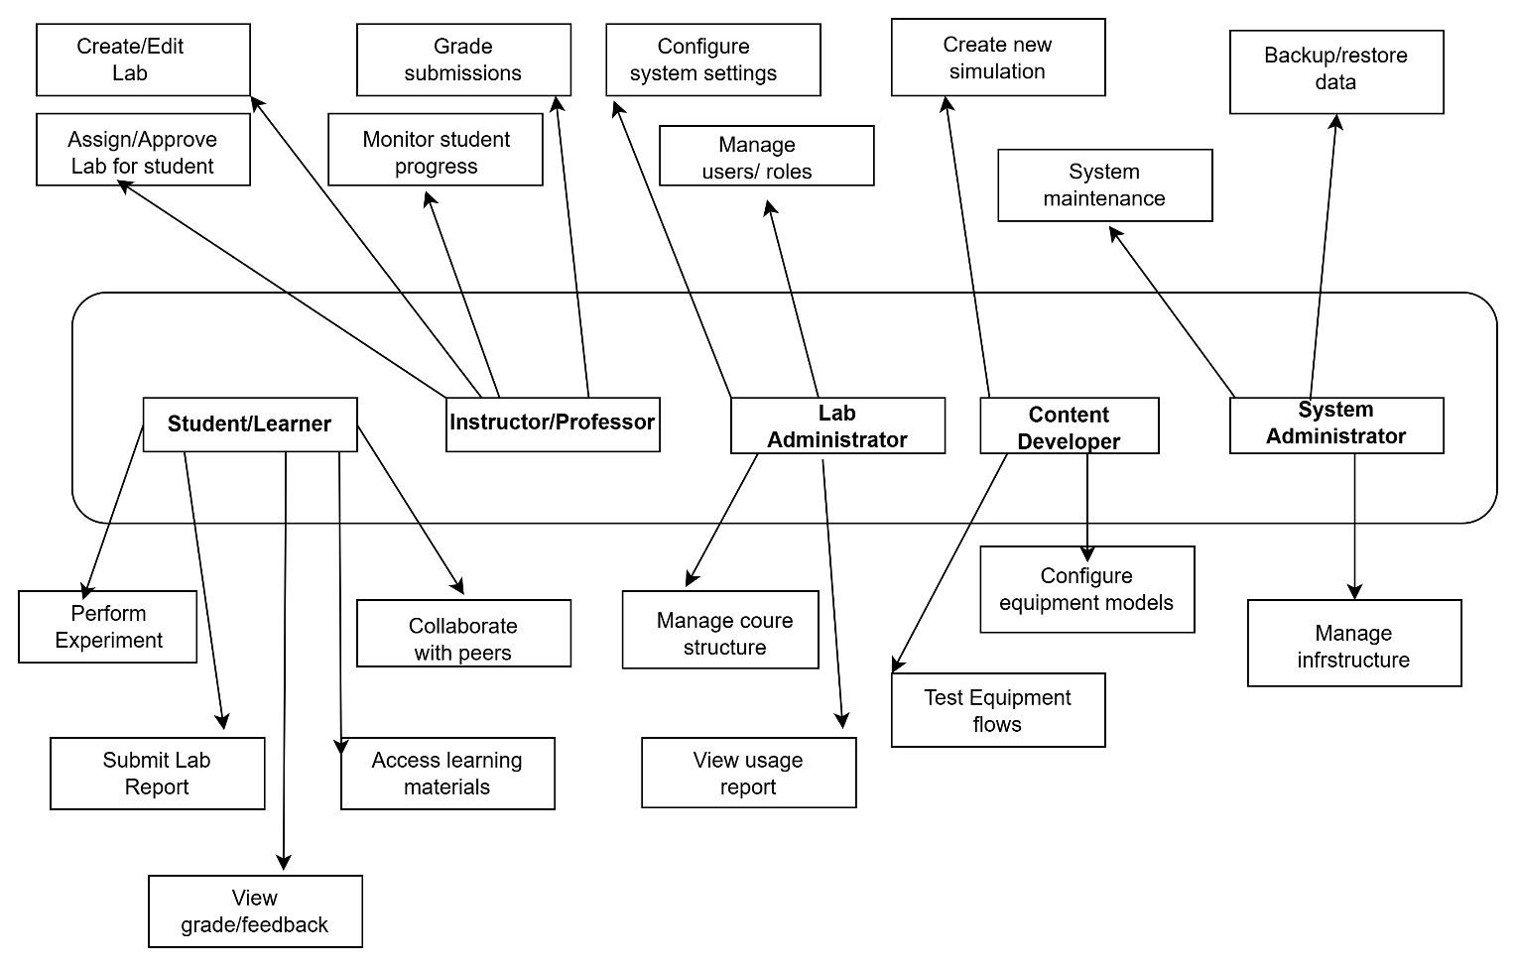
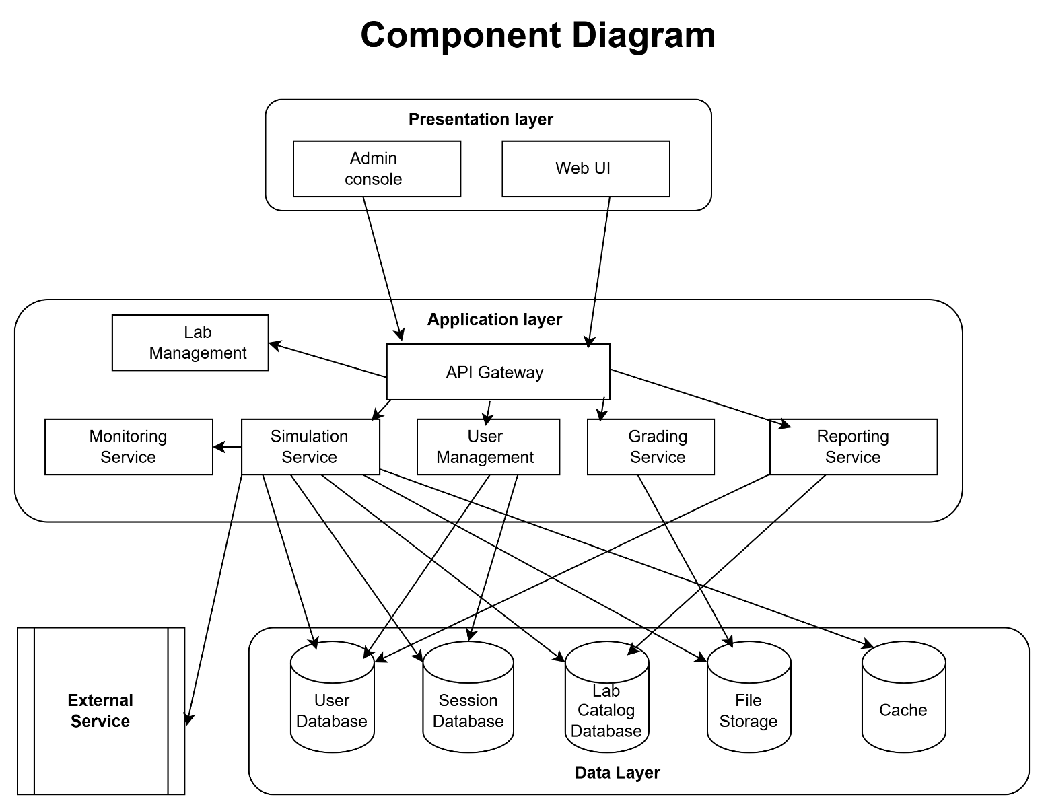

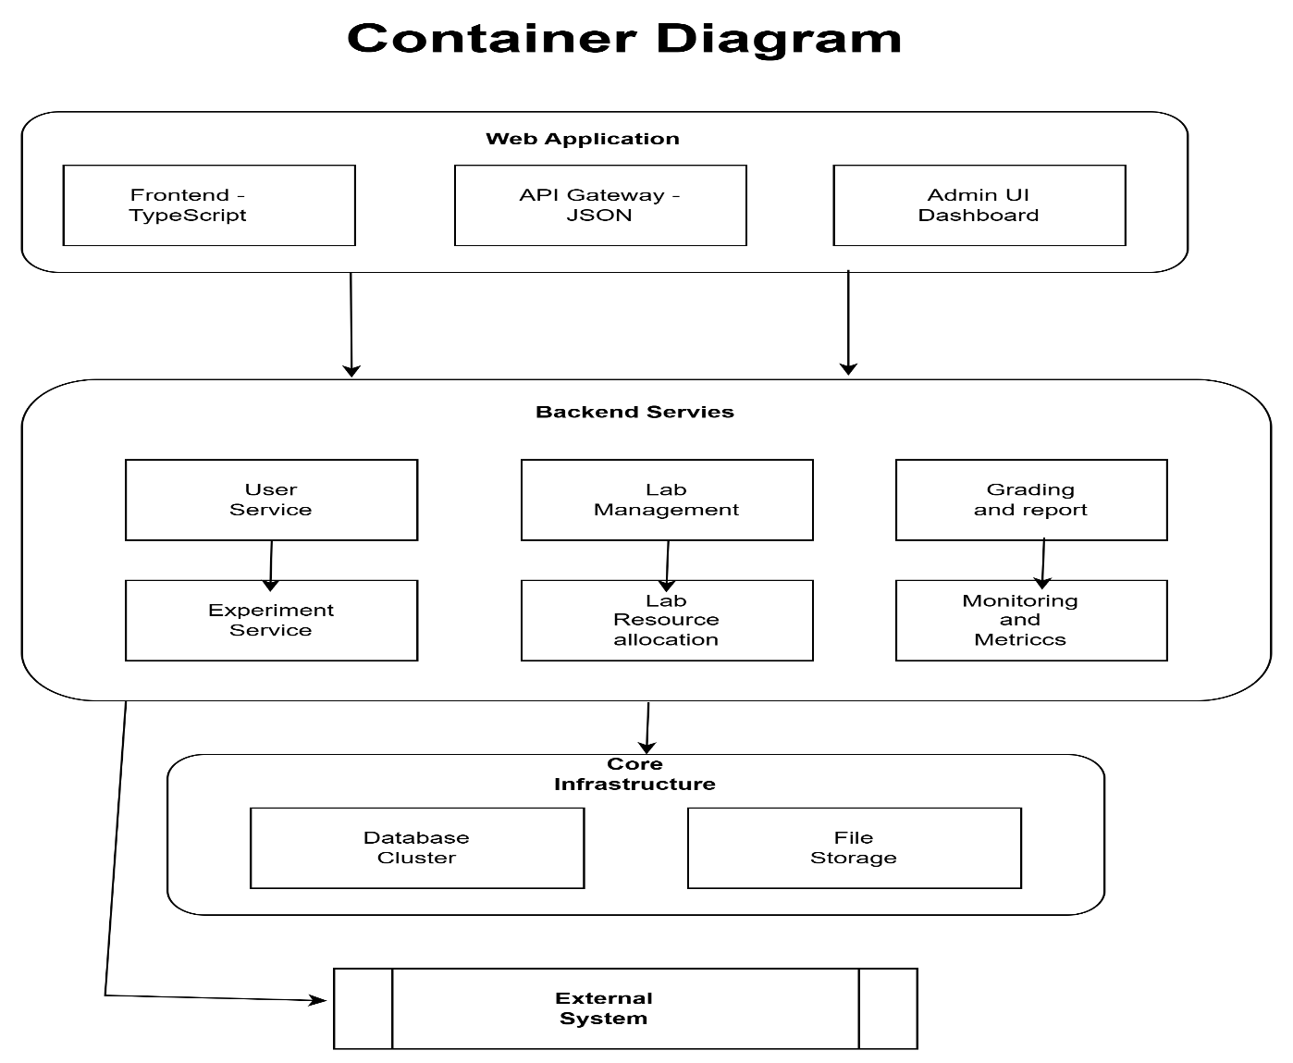

Quality Attribute Achievement Strategy
QA Scenario QA-1: Performance (Simulation Response Time)
Architectural tactics applied
· Precompute simulation datasets per run rather than recalculating during rendering
· Separate simulation computation from UI rendering using a simulation module layer
· Reduce unnecessary React re-renders using useReducer, memoization, and scoped state
· Canvas rendering driven by requestAnimationFrame with state held in refs (not React state)
Supporting architecture elements
· Simulation module interface (pure TypeScript functions)
· Lab Player shell with isolated state store
· Canvas renderer component using refs + requestAnimationFrame
· Results and chart components that consume precomputed arrays
How this achieves the scenario
When a student runs a simulation (stimulus), the simulation engine computes trajectory or generation data once and returns a typed dataset. The Lab Player updates results and charts from that dataset without additional computation. Canvas animation replays the precomputed points without triggering React renders each frame. This keeps UI updates responsive and supports the target of results updating within 2 seconds for typical runs.
QA Scenario QA-2: Performance (AI Guidance Latency)
Architectural tactics applied
· Use a backend AI gateway to standardize requests and responses and avoid client-side credential handling
· Send compact, structured lab snapshots rather than large logs or raw datasets
· Provide immediate UI feedback (loading state) while the AI request is in flight
· Implement timeouts and retry behavior without blocking simulation use
Supporting architecture elements
· AI gateway endpoint (REST, for example /api/ai)
· LabSnapshot builder (inputs, key outputs, last 10 actions)
· AI Coach panel with request state management (loading, error, retry)
How this achieves the scenario
When a student requests AI guidance (stimulus), the frontend sends a small snapshot payload to the AI gateway and immediately shows a loading state. The gateway forwards the request to the AI provider and returns a response. If the provider is slow, the UI remains responsive and the lab remains usable. This supports the target of a visible response within 8 seconds for most requests and a loading indicator within 250 ms.
QA Scenario QA-3: Reliability (Session Continuity During AI Failure)
Architectural tactics applied
· Preserve lab state independently from AI calls so failures do not reset the lab
· Treat AI as an enhancement, not a dependency for running simulations
· Provide graceful error handling and retry without losing context
· Centralize AI error handling in a single integration layer
Supporting architecture elements
· Lab state store (inputs, outputs, run history, event log)
· AI request wrapper with consistent error mapping and retry support
· UI error states in the AI Coach panel that do not affect Lab Player state
How this achieves the scenario
If the AI provider times out or returns an error (stimulus), the AI Coach panel shows a clear error message and a retry button, while the lab’s current inputs, outputs, charts, and canvas state remain unchanged. This ensures no loss of session progress and allows recovery without restarting the lab.
QA Scenario QA-4: Security (API Key and Data Protection)
Architectural tactics applied
· Route all AI requests through a server-side gateway to keep secrets off the client
· Store credentials only in server environment variables or secret storage
· Limit request content to non-sensitive, structured lab snapshots
· Avoid persistent storage of student data in the MVP
Supporting architecture elements
· Backend AI gateway service deployed in an AWS container
· Server-side secret management (environment variables, AWS secrets option)
· Frontend-only access to gateway endpoint, not the AI provider directly
How this achieves the scenario
If someone attempts to extract an API key from the browser or call the AI provider directly (stimulus), they cannot because the key is never shipped to the client. The client only communicates with the gateway endpoint, which uses server-side secrets to call the AI provider. Because the snapshot contains only lab state and no sensitive personal data, data exposure risk is minimized. This satisfies the requirement that API keys are never exposed in client-side code or network responses.
QA Scenario QA-5: Usability (Learnability and Clarity)
Architectural tactics applied
· Provide a consistent Lab Player shell across all labs to reduce cognitive load
· Enforce input validation and guardrails to prevent invalid runs
· Use clear information hierarchy: objective, controls, results, guidance
· Provide quick-action AI buttons (Explain, Hint, Check Reasoning) to support learning flow
Supporting architecture elements
· Reusable UI components and layout system (navigation, cards, controls panel)
· Validation utilities at the input boundary
· Standard lab metadata (objective text, instructions, default values)
· AI Coach panel integrated into Lab Player
How this achieves the scenario
When a new user opens a lab for the first time (stimulus), the consistent layout and clear instructions reduce confusion, while validation prevents invalid runs and provides immediate feedback. The user can run a first experiment quickly and use AI guidance to understand results. This supports the goal that a new user can successfully run a lab and view results within about 2 minutes, with the system preventing invalid runs through clear guardrails.
Technology Selection Rationale: Programming languages and frameworks
Frontend language: TypeScript
Rationale
· Supports correctness for simulation inputs and outputs through strong typing, which reduces runtime errors in logic-heavy lab modules.
· Improves maintainability and team collaboration by making the domain model explicit (Lab, Course, Module, LabSnapshot).
· Enables safer refactoring as new labs and UI flows are added during the short execution window.
Frontend framework: React
Rationale
· Fits the modular monolith approach because labs, course modules, and the Lab Player can be implemented as composable components with clear boundaries.
· Supports rapid iteration through component reuse and predictable UI state updates, which is critical given the practicum timeline.
· Strong integration with TypeScript improves code quality and reduces integration friction across team members working in parallel.
Build tooling: Vite
Rationale
· Fast local development and hot reload reduce iteration time, which matters when the UI and simulations require frequent tuning.
· Simple configuration keeps focus on product delivery rather than build system overhead.
Routing: React Router
Rationale
· Enables clear navigation between Home, Courses, Labs, and Lab Player without introducing backend dependencies.
· Supports deep linking to specific labs and course pages, improving usability and demo readiness.
Styling: Tailwind CSS
Rationale
· Allows rapid, consistent UI development without maintaining large custom CSS files.
· Encourages reusable UI patterns (cards, layouts, controls), improving maintainability and reducing UI “clunkiness” risk.
Visualization: Recharts
Rationale
· Integrates cleanly with React and supports the platform’s performance and usability goals through responsive data-driven charts.
· Allows quick delivery of meaningful result visualizations without building chart primitives from scratch.
Simulation rendering: HTML5 Canvas
Rationale
· Provides a performant way to render interactive animations without heavy dependencies.
· Works well with the performance scenario by allowing animation loops to run outside React render cycles.
AI guidance UI: Custom chat components
Rationale
· Keeps the UI lightweight and tailored to the lab workflow (quick actions, context snapshots) rather than forcing a generic chat pattern.
Database choices and rationale
Current iteration (MVP)
· No database is used. The project explicitly excludes authentication, persistent user progress, and analytics to avoid backend complexity and protect schedule and scope.
Planned extension (if persistence is introduced later)
· Relational database (PostgreSQL) would be the default choice for course content, lab metadata, and user progress due to strong schema support and consistency.
· A lightweight cache (Redis) would be considered only if AI response caching or rate-limiting becomes necessary.
Infrastructure and deployment platform
Development workflow
· Local development on team machines with collaboration through GitHub (branching and pull requests).
Planned deployment
· AWS container-based deployment to provide a consistent runtime environment and an easy path to scale if needed.
· Containers allow bundling the frontend and a small backend gateway (for AI requests) with consistent configuration across environments.
Integration technologies
Internal integration
· Component communication via props, hooks, and context.
· A lab module interface and registry pattern to integrate new labs without changing core flows.
External integration
· REST over HTTPS for AI requests via a backend gateway endpoint (for example, /api/ai).
Rationale
· REST is simple, debuggable, and sufficient for request-response AI interactions.
· Keeps the system stateless and supports the security scenario by preventing client exposure of API keys.
Architectural Constraints and Assumptions
Constraints
1.Timeline constraint (8-week practicum, limited execution window)
Impact on architecture
· Forces a modular monolith approach over distributed services to reduce integration and deployment overhead.
· Limits scope to one high-quality simulation and a small set of core platform features.
2. Budget constraint (no dedicated funding)
Impact on architecture
· Requires low-cost or free tooling and a minimal infrastructure footprint.
· Encourages static frontend hosting and a small backend gateway only if needed for AI secrets.
3. Team capacity and skills constraint
Impact on architecture
· Architecture must be simple to onboard and contribute to in parallel, with clear module boundaries.
· Avoids complex orchestration, service meshes, or advanced distributed patterns that would consume time without improving the MVP.
4. Project requirements constraint (interactive simulation + AI guidance, no auth)
Impact on architecture
· Prioritizes client-side interactivity, Canvas rendering, and fast state management.
· Explicitly excludes persistent identity and progress tracking, reducing need for databases and user management services.
5. Dependency constraint (external AI provider)
Impact on architecture
· Requires a backend gateway pattern to protect API keys and standardize error handling.
· Demands graceful degradation so the lab remains usable even when AI is slow or unavailable.
Assumptions
1. Users will have access to a modern browser and stable internet
Rationale
· Required for Canvas-based animation, chart rendering, and AI API calls.
2. External AI services will be reachable during development and demos
Rationale
· AI guidance is a core feature, but the architecture assumes occasional failures and includes retry and fallback handling.
3. Simplified scientific models are acceptable for an educational prototype
Rationale
· The project is focused on learning outcomes and architectural quality, not high-fidelity scientific accuracy.
4. User sessions are short and primarily exploratory
Rationale
· Supports the decision to avoid authentication and long-term persistence in the MVP.
5. AWS container infrastructure will be available for deployment when needed
Rationale
· The deployment plan assumes the team can provision an AWS container service for the demo environment.
Architectural Risks and Mitigation
1. Risk: UI performance issues (slow simulation rendering or laggy interaction)
Impact: High
Mitigation
· Keep simulation logic pure and decoupled from UI.
· Precompute datasets per run and animate from arrays.
· Use Canvas refs and avoid React re-renders per animation frame.
· Add performance budgets early (for example, results update target within 2 seconds).
2. Risk: AI dependency causes unreliable demos (timeouts, rate limits, provider outages)
Impact: High
Mitigation
· Treat AI as an enhancement, not a blocker to running labs.
· Preserve lab state and allow retry without losing work.
· Add a fallback mode with mocked responses for demos if needed.
· Use a backend gateway to centralize timeouts, retries, and logging.
3. Risk: Scope creep expands platform features beyond timeline
Impact: High
Mitigation
· Enforce MoSCoW prioritization and keep a strict “one simulation done well” rule.
· Lock scope boundaries in requirements and architecture docs.
· Push stretch features into a backlog and only address them after core success criteria are met.
4. Risk: Architecture becomes inconsistent as team members build in parallel
Impact: Medium
Mitigation
· Use a feature-folder structure with shared coding conventions.
· Require PR reviews and basic linting to maintain standards.
· Define a lab module interface early so new labs follow the same pattern.
5. Risk: Security mistakes expose API keys or sensitive configuration
Impact: Medium to High
Mitigation
· Keep AI keys strictly server-side.
· Route AI calls through a gateway endpoint only.
· Avoid collecting personal data in the MVP.
· Review network requests during testing to confirm secrets are not exposed.
Team Architecture Review Summary
Date and attendees
The team conducted an architecture review meeting on January 28, 2026, at 6:00 PM Central Time via Zoom. All three team members were present: Ahmed Kareem, Gideon Idowu, and Nathan Gulley.
Feedback received from team members
The primary focus of the discussion was the overall architectural direction of the system, specifically whether STEMulator should follow a purely monolithic architecture, a server-based architecture, or a combination of both. The team also reviewed how the AI integration should be structured and whether it should reside entirely in the frontend or be separated into a backend service.
Additional feedback included recommendations to keep the initial system lightweight, avoid unnecessary distributed complexity, and ensure that the architecture supports future extensibility without overengineering the MVP. There was also discussion around how educational data (labs, courses, modules) should be modeled to support reuse and scalability.
Changes made based on feedback
Based on the team discussion, the architecture was refined from an initial frontend-only monolithic approach to a hybrid modular monolith with a backend AI gateway. This change ensures that core application logic remains centralized in the frontend, while sensitive AI integration is handled server-side for security and reliability.
The team also made changes to the data model by introducing clearer TypeScript interfaces for Labs, Courses, Modules, and Lab Snapshots. This improved type safety, clarified system boundaries, and made it easier to extend the platform with additional labs and educational content.
Team approval and consensus
All team members agreed on the hybrid architectural approach and approved the revised design. Consensus was reached that this architecture best balances technical rigor, security, and practicality within the eight-week practicum timeline, while still leaving room for future scalability and feature growth.

